ASSIGNMENT NO.3
Conditional Queries and Data Filtering

Q1) Create a database named CollegeDB and a table named Student.
The table should contain the following columns:
Column Name Data Type
Constraint
StudentID
INT
PRIMARY KEY
StudentName
VARCHAR(50)
Age
INT
Course
VARCHAR(30)
City
VARCHAR(30)
Marks
INT
Email
VARCHAR(60)
Insert at least 10 records into the table. Some records should contain NULL values in the Email
column.

CREATE DATABASE JuniorCollegeDB;
USE JuniorCollegeDB;

CREATE TABLE Student (
StudentID INT PRIMARY KEY,
StudentName VARCHAR(50),
Age INT,
Course VARCHAR(30),
City VARCHAR(30),
Marks INT,
Email VARCHAR(60)
);

INSERT INTO Student (StudentID, StudentName, Age, Course, City, Marks, Email)
VALUES
(1, 'Aarav Shah', 18, 'BSc IT', 'Mumbai', 85, 'aarav@email.com'),
(2, 'Meera Joshi', 19, 'BCA', 'Pune', 75, NULL),
(3, 'Rohan Patil', 20, 'BSc IT', 'Nashik', 92, 'rohan@email.com'),
(4, 'Ananya Desai', 19, 'BSc', 'Mumbai', 81, 'ananya@email.com'),
(5, 'Karan Mehta', 21, 'BCA', 'Pune', 68, NULL),
(6, 'Neha Sharma', 18, 'BSc IT', 'Mumbai', 88, 'neha@email.com'),
(7, 'Aditya Verma', 20, 'BSc', 'Nashik', 72, NULL),
(8, 'Priya Singh', 19, 'BCA', 'Pune', 95, 'priya@email.com'),
(9, 'Rahul Rao', 21, 'BSc IT', 'Mumbai', 79, 'rahul@email.com'),
(10, 'Sneha Iyer', 20, 'BSc', 'Nashik', 84, NULL);

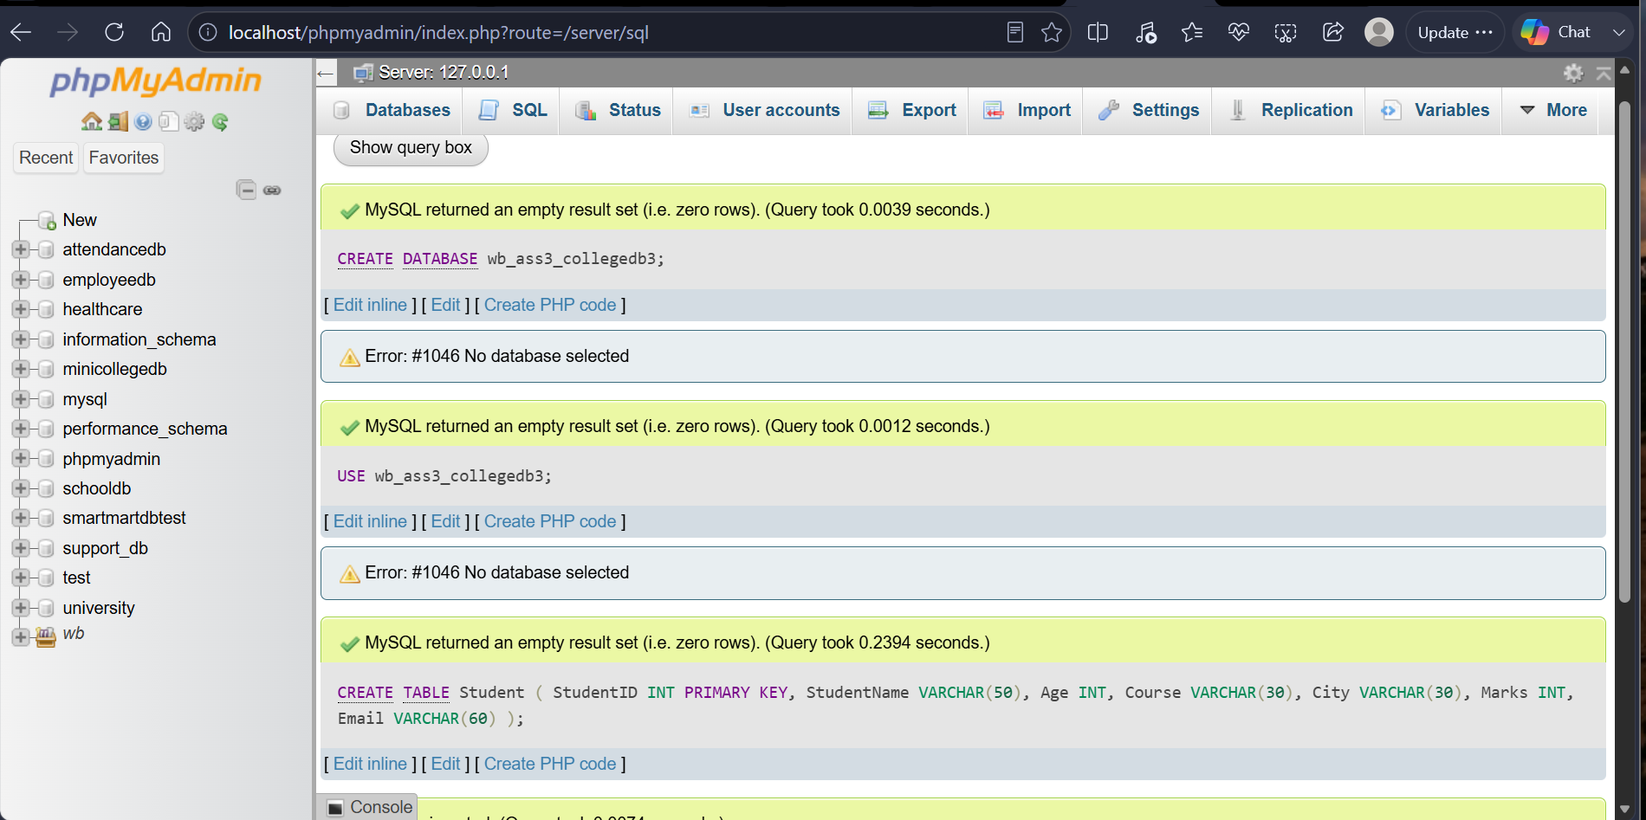

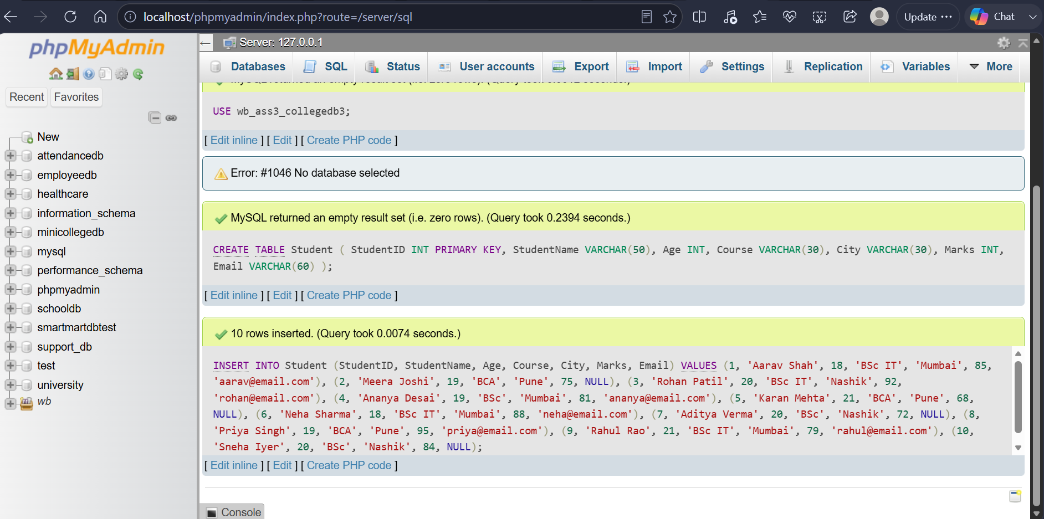
Q2) Write a MySQL query to display students who are from Mumbai and have marks greater than 80. The output should include
Column
StudentID
StudentName
City
Marks

SELECT StudentID,
StudentName,
City,
Marks
FROM Student
WHERE City = 'Mumbai'
AND Marks > 80;

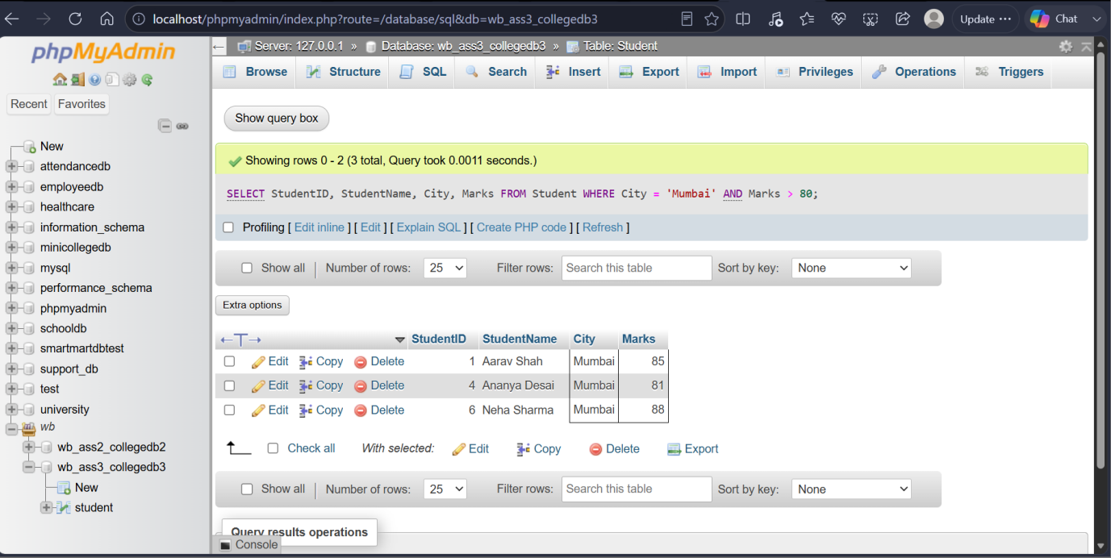

Q3) Write a MySQL query to display students who belong to either Pune or Nashik. Use the OR operator and display the following columns:
Column
StudentName
Course
City

SELECT StudentName, Course, City
FROM Student
WHERE City = 'Pune' OR City = 'Nashik';

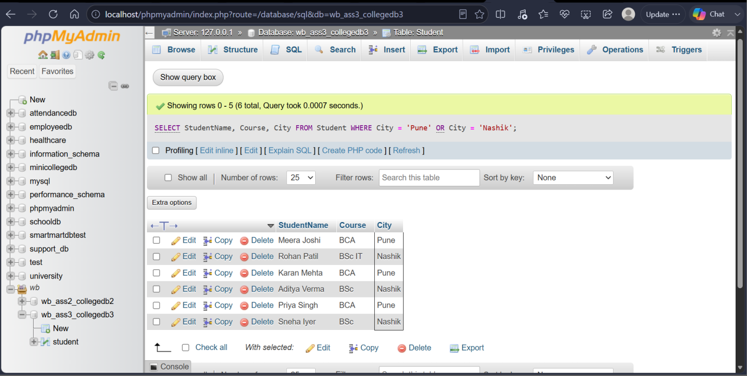

Q4) Write a MySQL query to display students whose marks are between 70 and 90. Use the BETWEEN operator and display:
Column
StudentName
Marks

SELECT StudentName, Marks
From Student
Where Marks BETWEEN 70 AND 90;

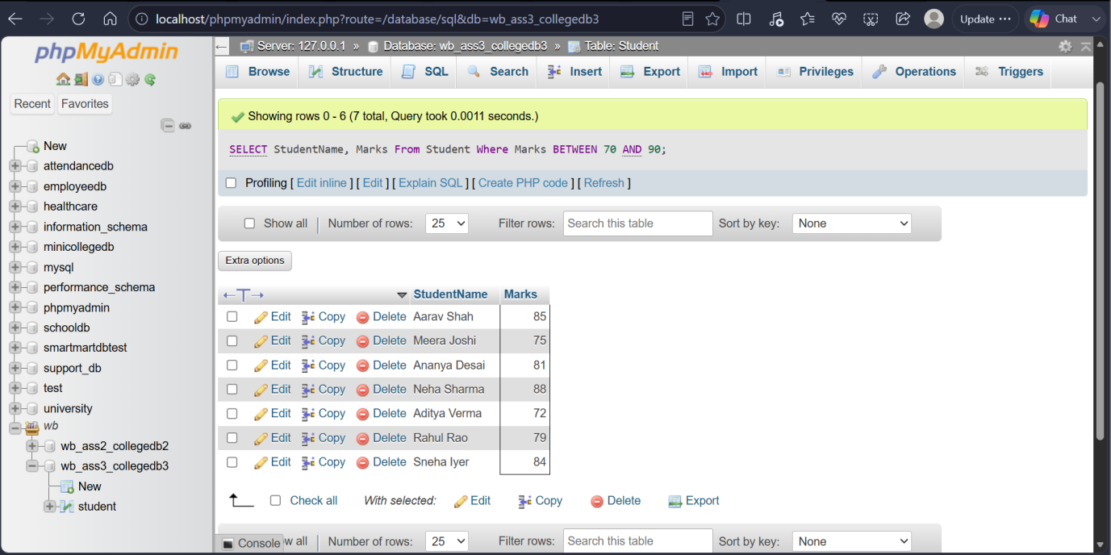

Q5) Write a MySQL query to display students whose names start with the letter A. Use the LIKE operator and display:
Column
StudentID
StudentName

SELECT StudentID, StudentName
FROM Student
WHERE StudentName LIKE 'A%';

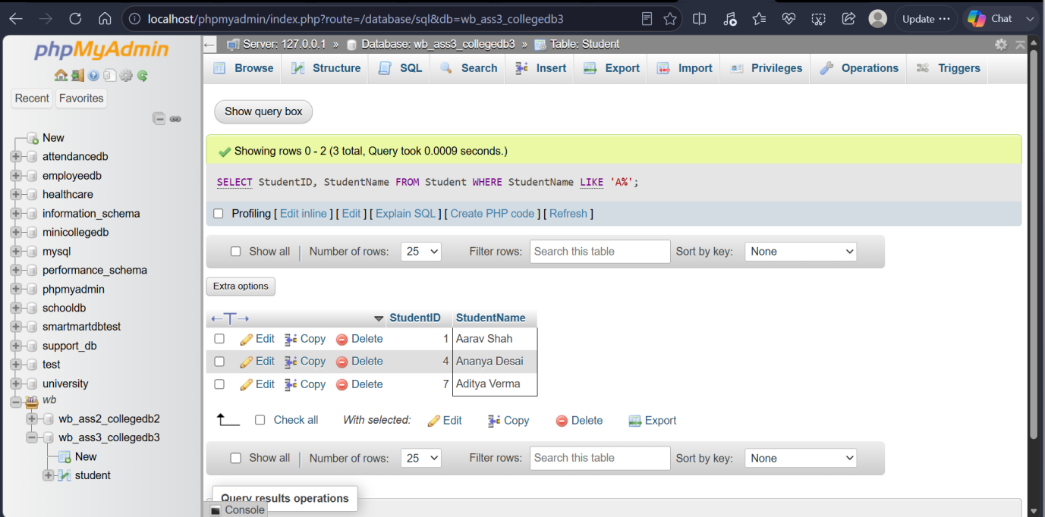

Q6) Write a MySQL query to display students whose email address is missing. Use the IS NULL operator and display:
Column
StudentID
StudentName
Email

SELECT StudentID, StudentName, Email
From student
Where Email IS NULL;

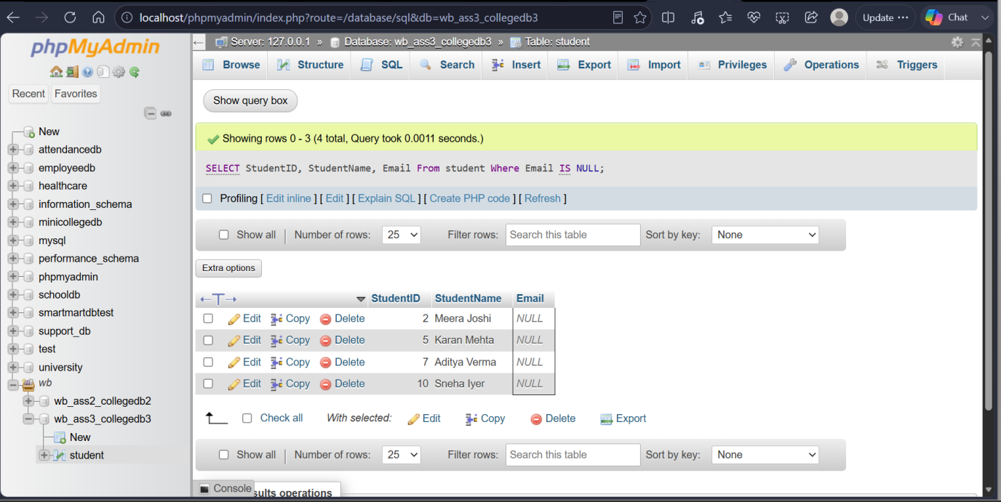

THANK YOU

